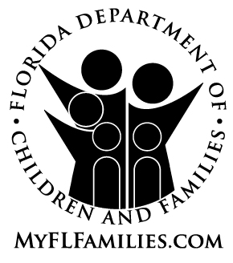 | EXTENDED FOSTER CARE (EFC) AGREEMENT

Name: |  | Date of Birth:

The date that I will enter Extended Foster Care (EFC):

My option to remain in EFC according to section 39.6251, Florida Statutes, and chapter 65C-41, Florida Administrative Code, has been explained to me and I believe this decision is in my best interest. I agree that I will:

- Live in an approved supervised living arrangement;
- Meet face to face in my home with designated staff every month;
- Participate in ongoing transition and case planning; AND
- Participate in a qualifying activity.

The qualifying activity that I have chosen while remaining in EFC is (must select at least one):
Completing secondary education or a program leading to an equivalent credential;
Enrolled in an institution that provides postsecondary or vocational education;
Participating in a program or activity designed to promote or eliminate barriers to employment;
Employed at least 80 hours per month;
Unable to participate in any of the programs or activities listed above due to my physical, intellectual, emotional, or psychiatric condition that impairs my ability to perform one or more life activities, limiting my participation.*

*I understand that if my condition limits or causes me to be incapable of participating, the incapability or barrier to participation must be supported with documentation from a clinical health care professional and will be addressed in my young adult case plan.

Signed:

______________________________________________ ______________
Youth Date (mm/dd/yyyy)

______________________________________________ ______________
Designated Staff Date (mm/dd/yyyy)

Designated staff shall provide a copy to the youth and attach a copy to the Transition Plan that is filed with court at the last review hearing before the child’s 18 birthday.

