# Mindshare Caregiver Court Notification and Response Form Process

Contents

**Step 1: CLS Enters Upcoming Hearing** 1

**Step 2: Email Address Entered for Provider** 1

**Step 3: Email Sent to Provider** 2

**Step 4: Provider Completes Court Input Form** 3

The process of notifying the caregiver of an upcoming court hearing and providing them with a link to complete the Caregiver input form is like a carefully orchestrated symphony where many players have an important role for the process to work.

## **Step 1: CLS Enters Upcoming Hearing**

CLS enters the pending hearings in the FSFN legal module. This is the first step in identifying which children have an upcoming hearing. Review the Mindshare dashboard “Upcoming Court Hearings” to view all future court dates. The future court date is on the dashboard if entered as follows:

* Scheduled or Completed Date is a future date
* Result = “Pending”

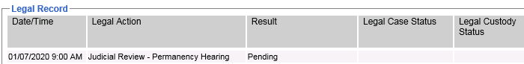

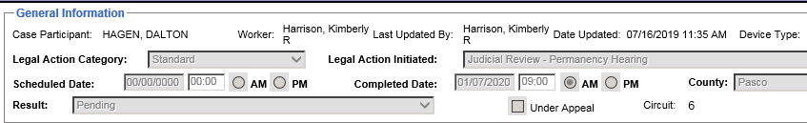

## **Step 2: Email Address Entered for Provider**

The next step is to ensure that each provider has an email address in the provider module. For licensed providers, this may be the responsibility of the provider specialist. For Relative and Non-Relative, the case manager needs to obtain the email and enter in the provider module.

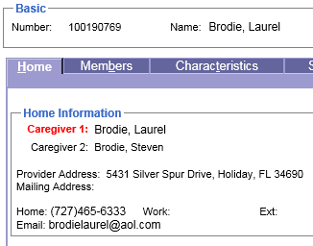

## **Step 3: Email Sent to Provider**

If steps 1 and 2 are entered, the provider (caregiver) is sent an email at 21 days prior to the hearing. The from address of the email is: [**notice@list.mindshare-tech.com**](mailto:notice@list.mindshare-tech.com)**.** It’s important for providers to not disregard this as junk mail – it’s safe to open the email. The email provides the upcoming court date as well as a link the caregiver can click on to complete the Caregiver input form. The email to the provider comes to their inbox with the subject line of “*NOTIFICATION: Family Court Hearing (‘Child Name’ – Hearing Type)”*



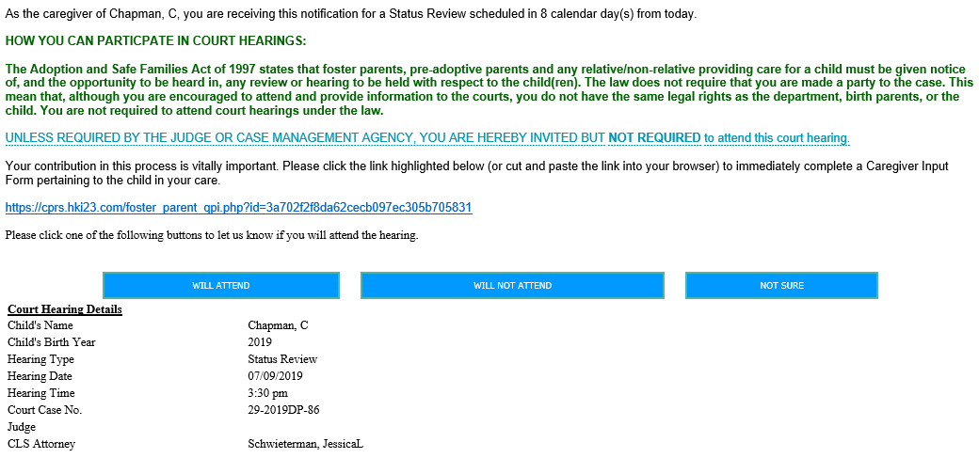

## **Step 4: Provider Completes Court Input Form**

Questions on form include:

* Do you plan to attend this Court Hearing in person or by phone?
* In general, what would you say is the emotional state of the child currently placed in your home?
* Does this child have any identified special needs? If yes, please explain.
* Please describe how the child is doing in school/daycare, behaviorally and academically.
* Please describe the activities enjoyed by the child in the home. If the child is of school age, this can include extracurricular activities. If none, what activities and/or hobbies does the child enjoy?
* Have there been any accomplishments at school or as part of any extracurricular activities (awards, honors of any type) that can be praised and acknowledged?
* In your opinion, what strengths does the child possess that can be encouraged?
* Are there any medical issues, medications or concerns (allergies, undesired medication side effects, medical diagnosis) that the court should be made aware of? If yes, please make sure to bring necessary documentation to hearing.
* Is the child taking psychotropic medications? If yes, please make sure to bring necessary documentation to hearing.
* Please describe any interaction you may have observed between the biological family and the child (parents, aunt, uncles, siblings, etc.)
* Are you involved in any co-parenting with the biological parents? If yes, kindly describe the level of co-parenting you are doing with the biological parents.
* Have you seen anything that concerns you about the biological parent(s)?
* Are there any issues and/or problems you wish to inform the Judge about?
* In what ways can we better support you?
* Do you have any positive feedback or areas of strength about the case that you would like to share with the court?

## **Step 5: Case Manager Receives PDF of Completed Form**

The primary case manager assigned to the case in FSFN will receive an email from [**notice@list.mindshare-tech.com**](mailto:notice@list.mindshare-tech.com)with a PDF attachment of the completed Caregiver Input form.