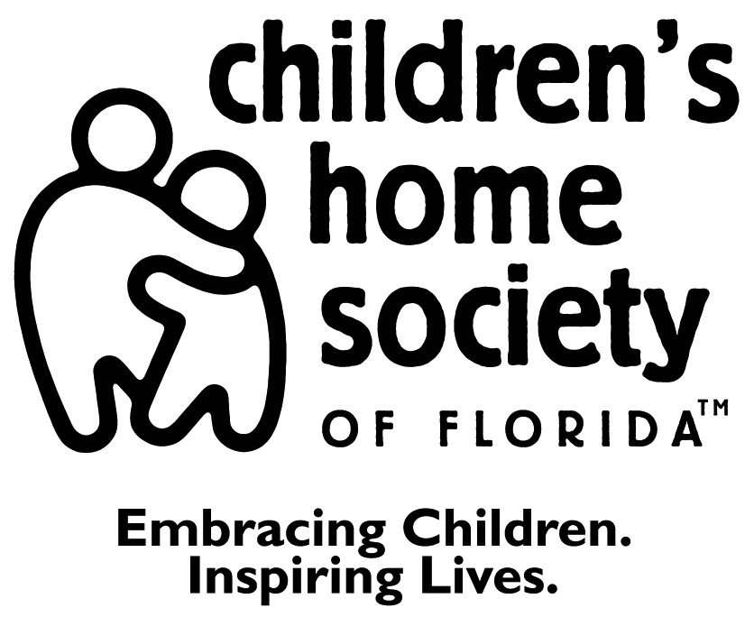

REFERRAL FORM for District 13
Family Team Coaching Program

CPI/KCI Supervisor | Telephone Number | CPI/KCI Case Worker | Telephone Number

CPI/KCI Office
Citrus |  | Hernando |  | Lake |  | Marion |  | Sumter

List All Children | Gender | Date of Birth | Race | Social Security Number

Parent(s) | Mother |  |  |  |  | Father
 | SS # |  |  |  |  | SS #
 | DOB |  |  |  |  | DOB
 | Race |  |  |  |  | Race
Other(s) in Home
Home Address |  |  |  |  |  | City |  |  | Zip
Home Telephone |  |  |  |  | Work Telephone
Parent(s) wanting to keep child(ren) in home?

***The following information must be attached to this Referral. Without these forms, the Family Team Coaching Program cannot accept the Referral.***

The Case Plan/Voluntary Case Plan Risk Assessment Current TANF Form

 | YES | NO
Does Family Have Medicaid?
TANF Eligible?
Is TANF Form Attached?
Is Risk Assessment Attached?
Have All Priors Been Attached?
Is Case Plan Attached?

Is Removal Imminent if this Service is Not Provided? |  |  |  |  |  |  |  |  | YES |  |  |  |  | NO
If so, Why? |  | Physical Abuse |  |  | Sexual Abuse |  |  | Substance Abuse |  |  |  |  | Neglect
 | Domestic Violence |  |  | Mental Health |  |  | Hazardous Conditions |  |  |  |  | Other

Date Referral Accepted: ___________________

Date Client Admitted: _____________________

Assigned to: ______________________

1 of 3

Children's Home Society of Florida Referral Form

Family Name:

What is the problem that got the family involved with a CPI investigation or KCI services?
What services do you feel Family Team Coaching can provide?

Does the family know about this referral? | YES |  | NO
Does the family want services? | YES |  | NO
Is the family ready to begin services immediately? | YES |  | NO
If Child is not in the home, will reunification occur in the next 30 days? | YES |  | NO |  | N/A
Are substance abusing parent(s) in substance abuse treatment? | YES |  | NO |  | N/A
Are parent(s) receiving mental health treatment? | YES |  | NO |  | N/A
Do any of the children have Comprehensive Behavioral Assessments? | YES |  | NO
Are parent(s) receiving treatment for DV, i.e.: BIP? Victim’s Counseling? | YES |  | NO |  | N/A
If no, are they willing to be evaluated and follow through with treatment recommendation? | YES |  | NO
Are known / suspected sex offenders living in the home? | YES |  | NO
If yes, please explain:

Are known / suspected sex offenders having contact with child(ren)? | YES |  | NO
If yes, please explain:

Are known / suspected sex offenders in treatment? | YES |  | NO

Page 2 of 3

Children's Home Society of Florida Referral Form

Family Name: __

Previous CHS Involvement? | YES |  | NO |  | NOT SURE

Other programs referred and dates:

Directions to client’s home:

_____________________________________________ _________________________
Referring CPI/Caseworker Signature Date

_____________________________________________ _________________________
Referring Supervisor Signature Date

_____________________________________________________________________________________________________
______________________________________________________________________________________________________________________________

Please submit to your local Service Center:

Children’s Home Society Children's Home Society Children's Home Society
Marion County Service Center Citrus County Service Center Lake County Service Center
11 N. Magnolia Avenue 2315 Highway 41North 1300 Duncan Drive, Building D
Ocala, FL 34475 Inverness, FL 34453 Tavares, FL 32778
352-732-1702 352-860-5149 352-742-6170

Children’s Home Society Children’s Home Society
Hernando County Harbor Building Sumter County Service Center
11331 Ponce DeLeon Boulevard 1601 West Gulf Atlantic Boulevard
Brooksville, FL 34601 Wildwood, FL 34785
    - 352-748-9999, Ext. 35

Page 3 of 3

Revised 8/13/08

